PRESENT CONTINUOUS TENSE

Form
The verb to be (in the simple present) | verb + ing

eat - jesti

Affirmative
I | am | eating.
 | ’m
You, we, they | are
 | ’re
He, she, it | is
 | 's

Questions
Am | I | eating?
Are | you, we, they
Is | he, she, it

Negative
I | am not | eating.
 | ’m not
You, we, they | are not
 | aren’t
He, she, it | is not
 | isn’t

Time expressions:

now, at the moment

Use
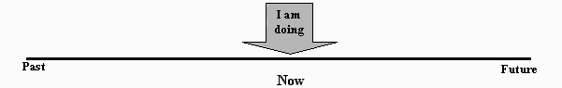
- The present continuous is used for actions happening at the time of speaking – now.
Example:
  - Where is Mary? She is having a bath. (! Not: She has a bath)
  - What are you doing at the moment in front of your screen? Don't you know? Well … you are reading this lesson. You are learning English.

