NUMERS 1-100
- Read and circle the correct ones.
SEVENTY | 7 | 17 | 70 | THIRTY | 20 | 30 | 40
EIGHT | 18 | 8 | 80 | ELEVEN | 11 | 12 | 13
NINE | 19 | 90 | 9 | FOURTEEN | 40 | 400 | 14
FIFTEEN | 5 | 15 | 50 | ONE | 1 | 10 | 100
A HUNDRED | 10 | 1000 | 100 | FOUR | 40 | 4 | 14

- Match.
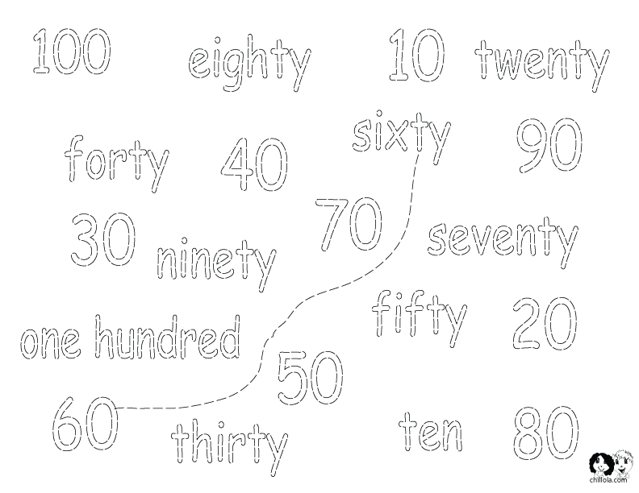
- Write.

