TEST
III grade March 2021
Name: ________________________________________________________

- HIS/HER/THEIR

- ______ dress is yellow. (Sarah)
- ______ shoes are green. (Tom and Jane)
- ______ T-shirt is white. (Anna)
- ______ jeans are blue. (Jason)
- ______ jackets are big. (Jack and Peter)

- 3.
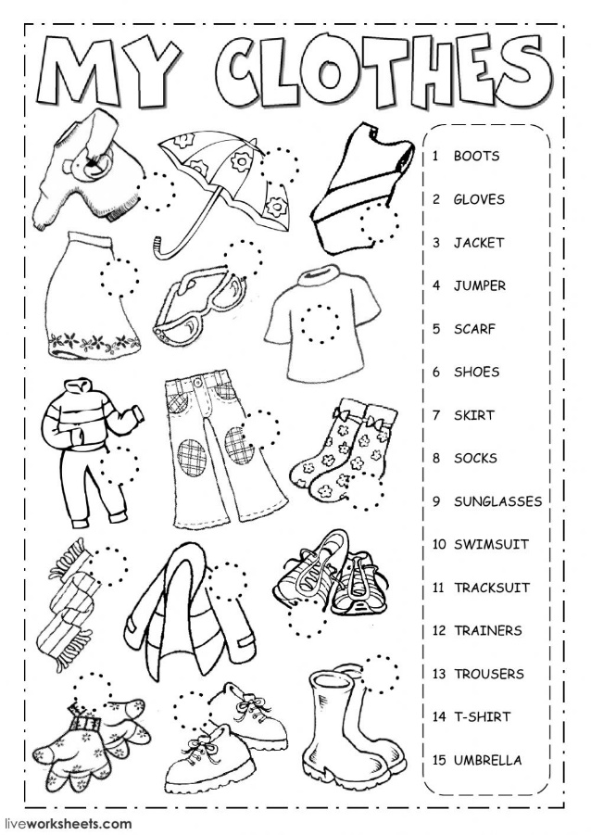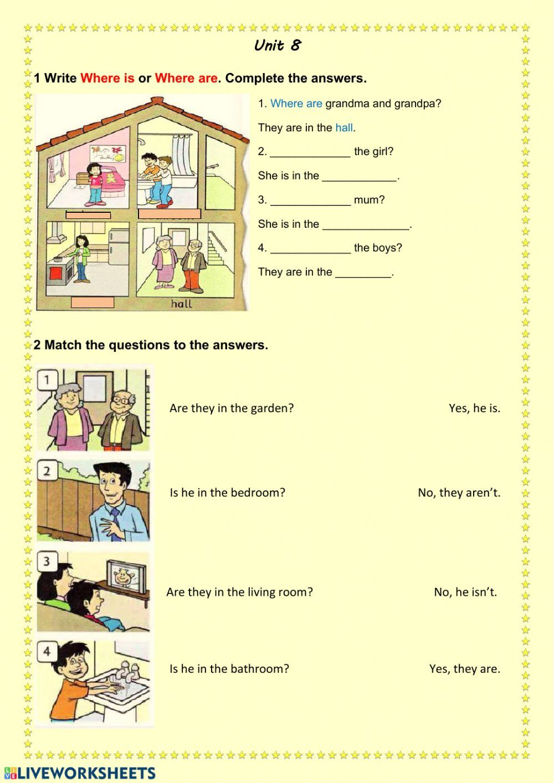
4.
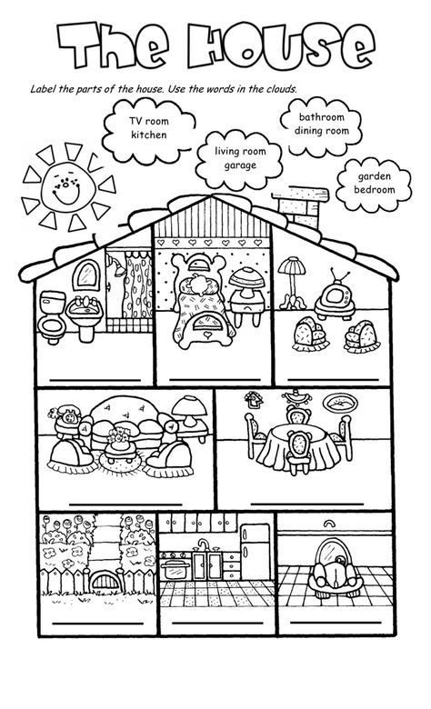
5. 