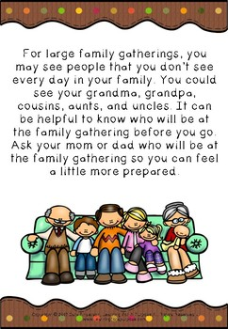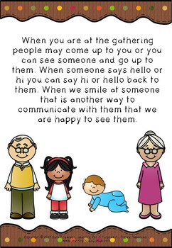

Write about your family.
_________________________________________________________________________________________________________________________________________________________________________________________________________________________________________________________________________________________________________________________________________________________________________________________________________________________________________________________________________________________________________________________________________________________________________________________________________________________________________________________________________________________________________________________________________________________________

