The Simple Past

(Prosto prošlo vreme)

Form

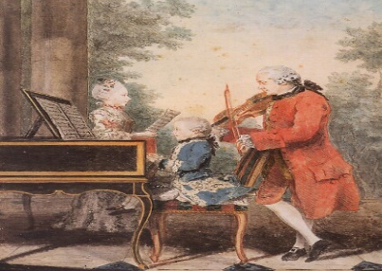
Wolfgang Amadeus Mozart was an Austrian musician and composer. He lived from 1756 to 1791. He started composing at the age of five years old and wrote more than 600 pieces of music. He was only 35 years old when he died.
The verbs "was, lived, started, wrote, died" are in the simple past tense.
Notice that:
- lived, started, died are regular past forms.
- was, wrote are irregular past forms.

Regular verbs (Pravilni glagoli):
The verbs "lived, started, died" are regular past forms. The rule is the following:
Verb + (e)d
Examples:
The infinitive | The simple past
live | lived
start | started
die | died
visit | visited
play | played
watch | watched
phone | phoned
marry | married

Irregular verbs (Nepravilni glagoli) – 2nd column, List of irregular verbs (2.kolona, Lista nepravilnih glagola)
The verbs "was, wrote" are irregular past forms. "Was" is the simple past of "to be"; "wrote" is the simple past of "write".
There is no rule for these verbs. You should learn them by heart.
The infinitive | The simple past
be | was/were
write | wrote
come | came
do | did
meet | met
speak | spoke

The forms of the simple past:

Affirmative
I, you, he, she, it, we, you, they | played
 | wrote
Examples:
- I played tennis with my friends yesterday.
- I finished lunch and I did my homework.

Questions
Did | I, you, he, she, it, we, you, they | play?
 |  | write?
Examples:
- Did you play basketball last weekend?
- Did you do your homework yesterday?

The Negative form of the simple past:
I, you, he, she, it, we, you, they | did not/didn't | play
 |  | write
- I didn't like the food served at the party last Saturday.
- I didn't eat it.

Use - Upotreba
The simple past is used for events finished in the past/ finished past actions.
Prosto prošlo vreme koristi se za događaje završene u prošlosti / radnje završene u prošlosti.
- William Shakespeare wrote Hamlet.
- Christopher Columbus discovered America in 1492.
- She finished her homework and went to the cinema.

Remember:
didn't is the short form of did not. You can say either:
- I did not play basketball, or
- I didn't play basketball.
Time expressions
yesterday – juče
five days ago, three months ago, etc. – pre pet dana, pre tri meseca, itd.
last week, last Saturday, last summer, etc. – prošle nedelje, prošle subote, prošlog leta , itd.

